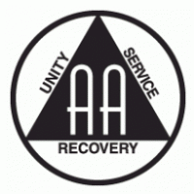
Service Opportunities for Men

Acceptance Recovery Center
- Monday at 7 PM
- Contact: Sean S.
  - 706-424-1200

Commencement Center
- Every other Friday at 1:30 PM
- Contact: Virginia V.
  - 229-328-9311
- Must have at least 1 year of sobriety

Miles Street
- Monday, Tuesday, Wednesday, Saturday at 8 PM
- Contact: Virginia V.
  - 229-328-9311

Twin Lakes Recovery Center
- Friday at 7 PM
- Contact: Hal C.
  - (706)-207-8102

Service Opportunities for Women

Freedom from Bondage
- Monday at 8 PM
- Contact: Jen B.
  - 478-396-2546

Women’s Services
- Thursday at 5:30 PM
- Contact: Jewell G.
  - 404-430-8981

Twin Lakes Recovery Center
- Friday at 7 PM
- Contact: Hal C.
  - (706)-207-8102

Commencement Center
- Friday at 1:30 PM
- Contact: Virginia V.
- 229-328-9311
- Must have at least 1 year of sobriety

Miles Street
- Monday, Tuesday, Wednesday, Saturday at 8 PM
- Contact: Virginia V.
  - 229-328-9311

